Exercise 1 — Tasks

1. Find the **title** of each film ✓

SELECT title FROM movies;

1. Find the **director** of each film ✓

SELECT director FROM movies;

1. Find the **title** and **director** of each film ✓

SELECT title, director FROM movies;

1. Find the **title** and **year** of each film ✓

SELECT title, year FROM movies;

1. Find **all** the information about each film ✓

SELECT * FROM movies

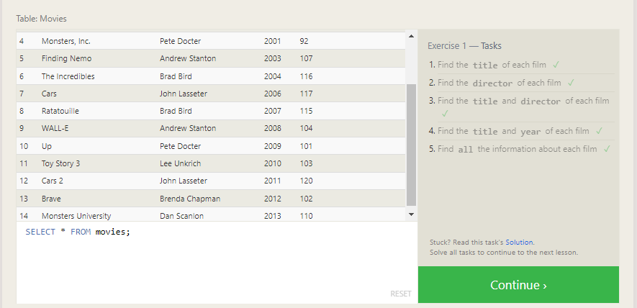

Exercise 2 — Tasks

1. Find the movie with a row **id** of 6 ✓

SELECT title FROM movies WHERE id=6;

1. Find the movies released in the **year**s between 2000 and 2010 ✓

SELECT title, year FROM movies WHERE year between 2000 and 2010;

1. Find the movies **not** released in the **year**s between 2000 and 2010 ✓

SELECT title, year FROM movies WHERE year NOT BETWEEN 2000 and 2010;

1. Find the first 5 Pixar movies and their release **year** ✓

SELECT title FROM movies WHERE id<6;

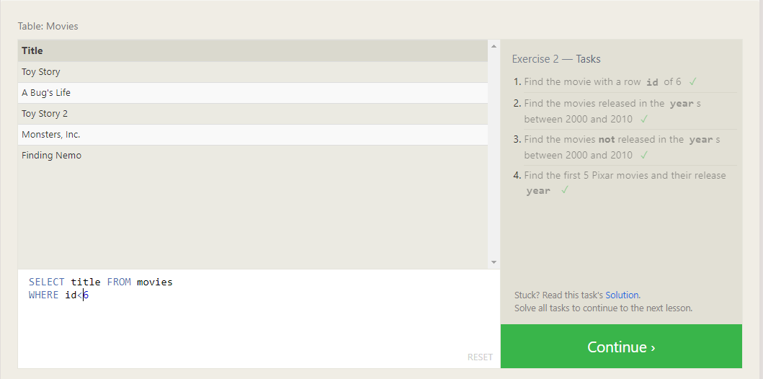

Exercise 3 — Tasks

1. Find all the Toy Story movies ✓

SELECT title FROM movies

WHERE title LIKE “Toy%”;

1. Find all the movies directed by John Lasseter✓

SELECT title FROM movies

WHERE director=”John Lasseter”;

1. Find all the movies (and director) not directed by John Lasseter✓

SELECT title, director FROM movies

WHERE director!=”John Lasseter”;

1. Find all the WALL-* movies✓

SELECT title FROM movies

WHERE title LIKE “WALL-_”;

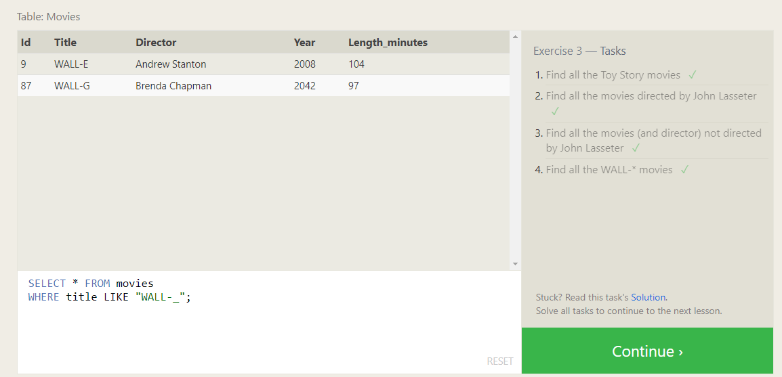

Exercise 4 — Tasks

1. List all directors of Pixar movies (alphabetically), without duplicates ✓

SELECT DISTINCT director FROM movies

ORDER BY director ASC;

1. List the last four Pixar movies released (ordered from most recent to least) ✓

SELECT title, year FROM movies ORDER BY year DESC LIMIT 4;

1. List the **first** five Pixar movies sorted alphabetically✓

SELECT title, year FROM movies

ORDER BY title ASC

LIMIT 5;

1. List the **next** five Pixar movies sorted alphabetically✓

SELECT title, year FROM movies

ORDER BY title ASC

LIMIT 5 OFFSET 5;

